  - Menu (Bottom Side) – Satellite
Test Items | Menu (Bottom Side) – Satellite
Preparations | 1.License: [Function] Map
Test Procedure | 1. Enter the map. (Refer to 1.1 How To Enter the Map)  2. Select Bottom Side Menu [] in the upper left corner.  3. bottom side Check the area.  4. Click Satellite [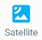] .
Criteria | 1. Check if the map is displayed with satellite image when turned on (On/Off)  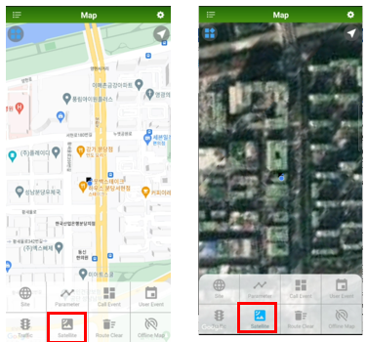

  - Menu (Bottom Side) – Router Clear
Test Items | Menu (Bottom Side) – Router Clear
Preparations | 1.License: [Function] Map
Test Procedure | 1. Enter the map. (Refer to 1.1 How To Enter the Map)  2. Select Bottom Side Menu [] in the upper left corner.  3. bottom side Check the area.  4. Click Route Clear [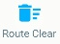].
Criteria | 1. If you click the Route Clear button, make sure that all routes are deleted.  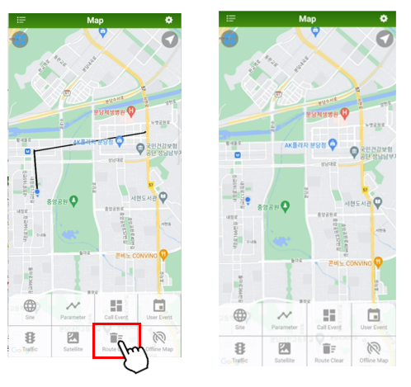

  - Menu (Bottom Side) – Offline Map
Test Items | Menu (Bottom Side) – Offline Map
Preparations | 1.License: [Function] Map
Test Procedure | 1. Enter the map. (Refer to 1.1 How To Enter the Map)  2. Select Bottom Side Menu [] in the upper left corner.  3. bottom side Check the area.  4. Click Offline Map[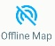].
Criteria | 1. A function that saves the map displayed on the current screen as an image so that it can be checked offline  (Save images in the XCAL-Mobile folder)  2. Check if the map is displayed by Network Off  3. Check the Google Map download success message.  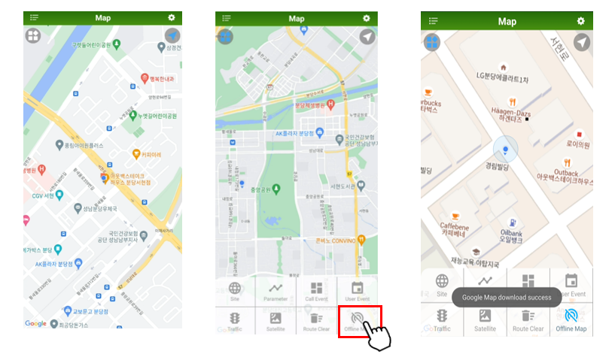

  - Setting (Right Side) – Site DB Update (Local Disk)
Test Items | Menu (Left Side) – Site DB Update (Local Disk)
Preparations | 1. License: [Function] M ap,  2. Site DB (path: \XCAL-Mobile\Settings\BTS\Local)  (For Site DB files, contact the administrator and refer to the BTS Manager Guide.)  3. Bottom side – Site On
Test Procedure | 1. Enter the map. (Refer to 1.1 How To Enter the Map)  2. Select Menu [ ] in the upper left corner.  3. Select Site DB UPdate (Local Disk).  4. Select Site DB from the list and proceed with the update. .  5. Verify that Site DB is applied to the map.  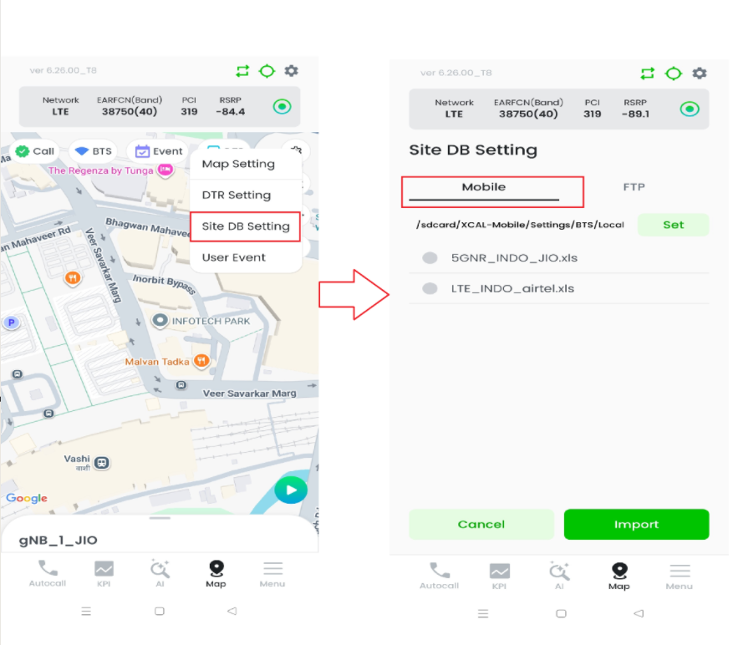
Criteria | 1. Verify that the Site DB loaded from the Local Disk is updated successfully  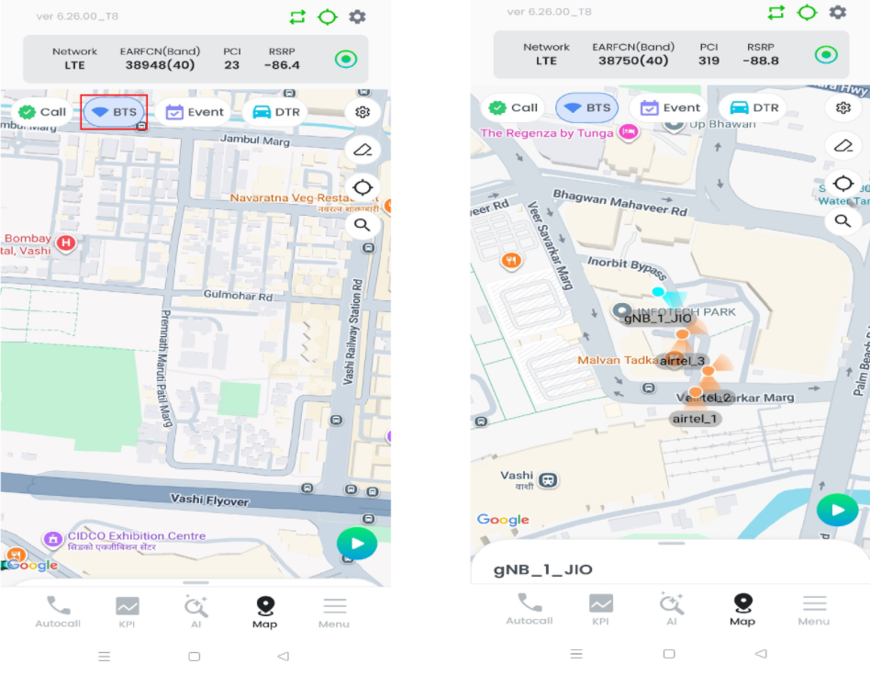

  - Setting (Right Side) – Site DB Update (FTP Server)
Test Items | Menu (Left Side) – Site DB Update (FTP Server)
Preparations | 1. License: [Function] Map,  2. FTP Server  (For FTP server, contact your administrator)  4. Bottom side – Site On
Test Procedure | 1. Enter the map. (Refer to 1.1 How To Enter the Map)  2. Select Menu [ ] in the upper left corner.  3. Site DB UPdate (FTP Server) 선택한다..  4. Enter FTP server info to connect and download Site DB from the FTP.  5. Check if the downloaded Site DB is automatically updated.  6. Verify that Site DB is applied to the map.  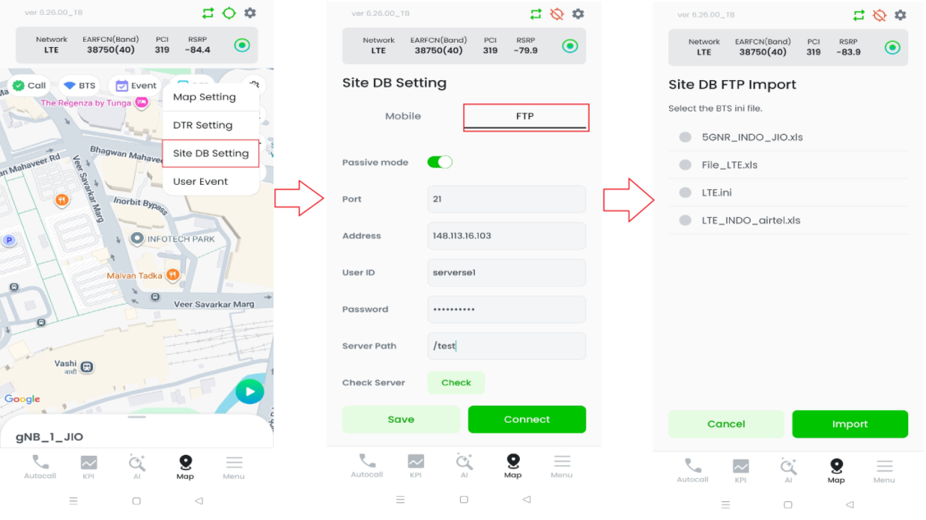
Criteria | 1. Verify that the Site DB downloaded from FTP Server is updated successfully  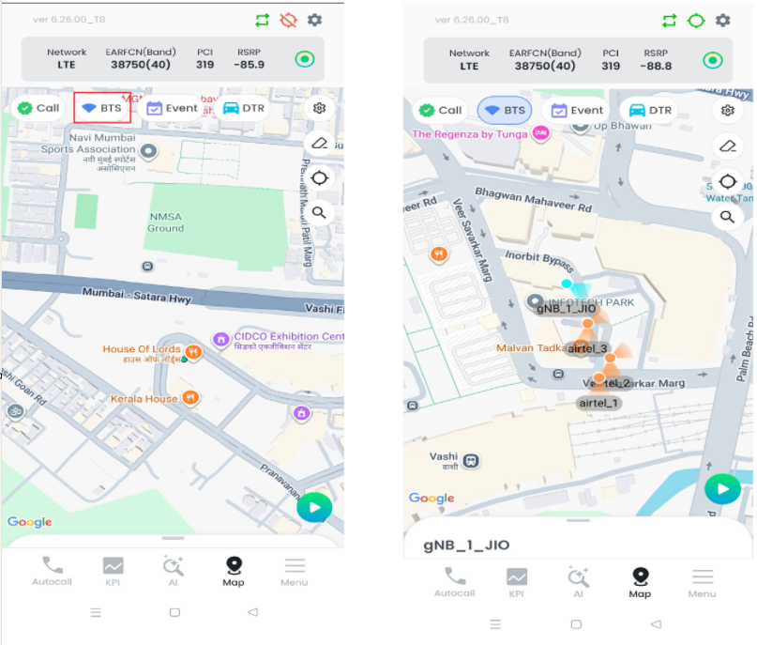

  - Setting (Second Option) – Site DB Clear
Test Items | Menu (Left Side) – Site DB Clear
Preparations | 1.License: [Function] Map,  2. Site DB  (For Site DB files, contact the administrator and refer to the BTS Manager Guide.)  3. Bottom side – Site On
Test Procedure | 1. Enter the map. (Refer to 1.1 How To Enter the Map)  2. Select Menu [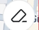 ] in the upper left corner.  3. Select ‘Site DB Clear’.  4. Check that Site DB is cleared on the map.  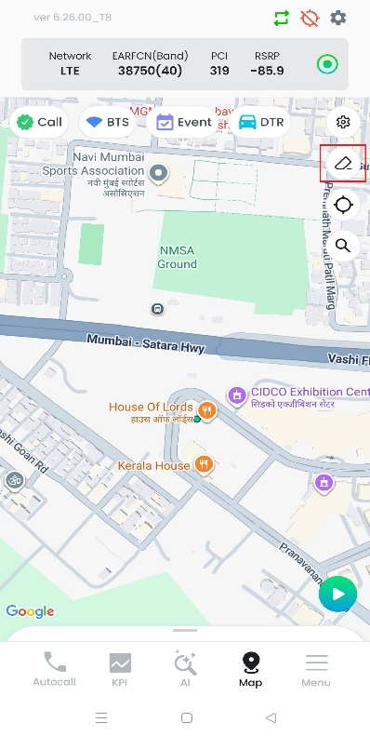
Criteria | 1. Check that Site DB is cleared on the map.  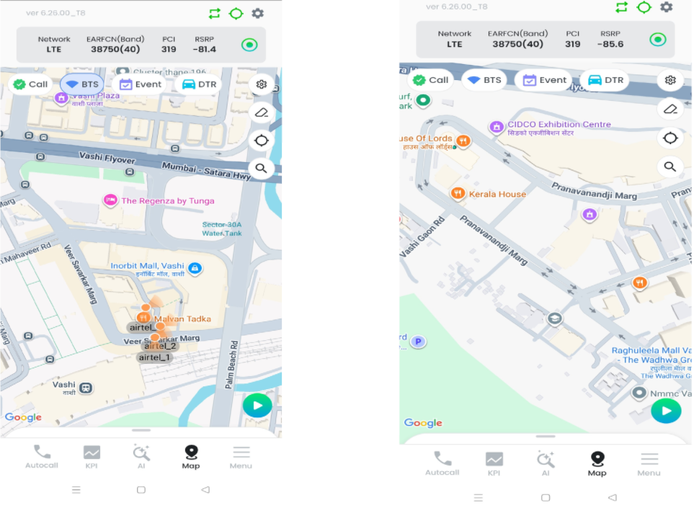

  - Menu (Left Side) – Site Display
Test Items | Menu (Left Side) – Site Display
Preparations | 1. License: [Function] Map,  2. Site DB  (For Site DB files, contact the administrator and refer to the BTS Manager Guide.)  3. Bottom side – Site On
Test Procedure | 1. Enter the map. (Refer to 1.1 How To Enter the Map)  2. Select Menu [ ] in the upper left corner.  3. Check the ‘Site Display’ area.  4. Try switching on/off 5G, 4G, 3G, and 2G displays.  5. Check if the map is applied after saving.  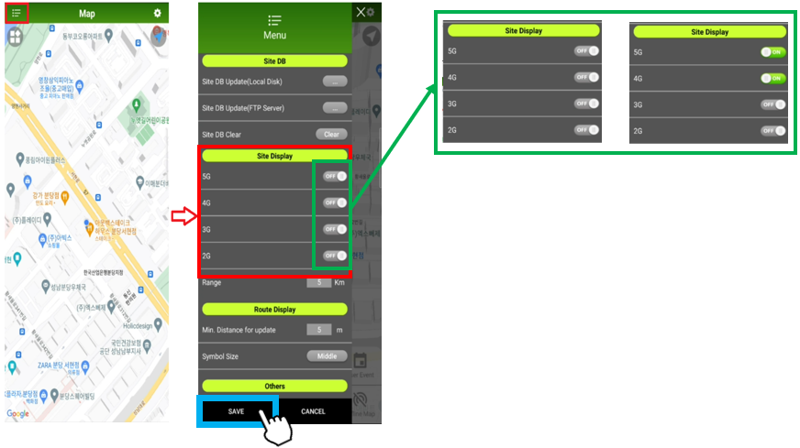  6. Check the ‘Range’ option, enter the value in KM (e.g. 1KM, 5KM, ….).  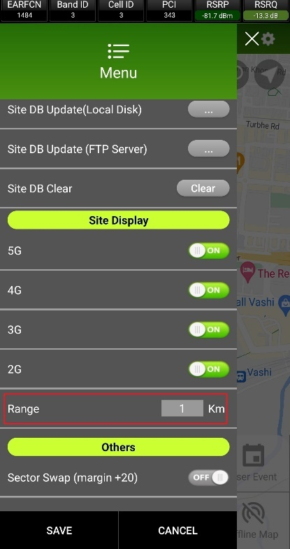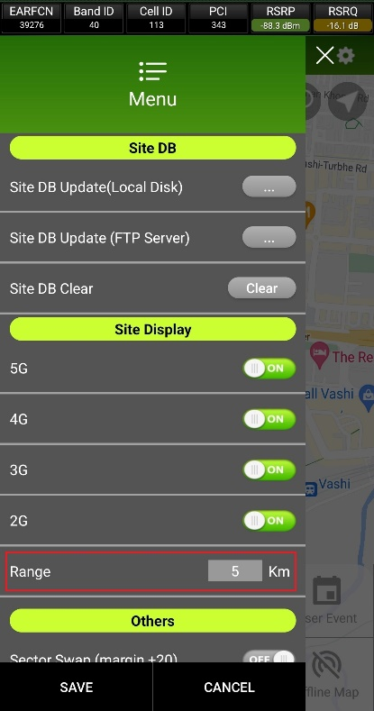
Criteria | 1. Switch the On/Off button to verify that the site loaded on the map can be (display/hidden) for the corresponding Tech  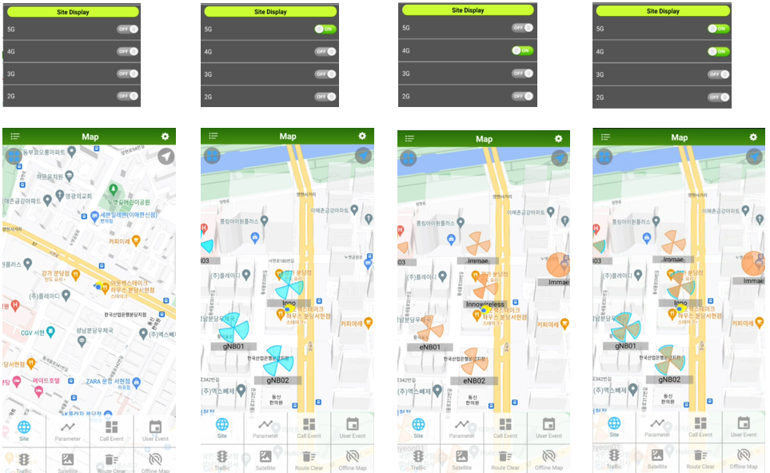  2. Check you can enter the value and search for ‘site information’ within the entered ‘range’. (e.g., check if you entered the range of 1km, and then you can search the Site information within 1 km.)  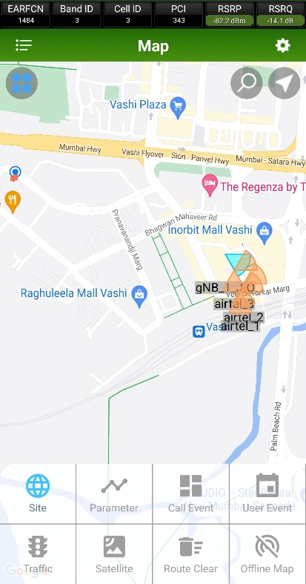

  - Menu (Left Side others) – Sector Swap (margin +20)
Test Items | Menu (Left Side) – Sector Swap(margin +20)
Preparations | 1. License: [Function] Map,
Test Procedure | 1. Enter Map. (See 1.1 MAP Entry Method for Map entry method).  2. Select Menu[] on the top left.  3. Check the Others area.  4. Try Sector Swap (margin +20) on/off.  5. After saving, check if it is applied to the map.  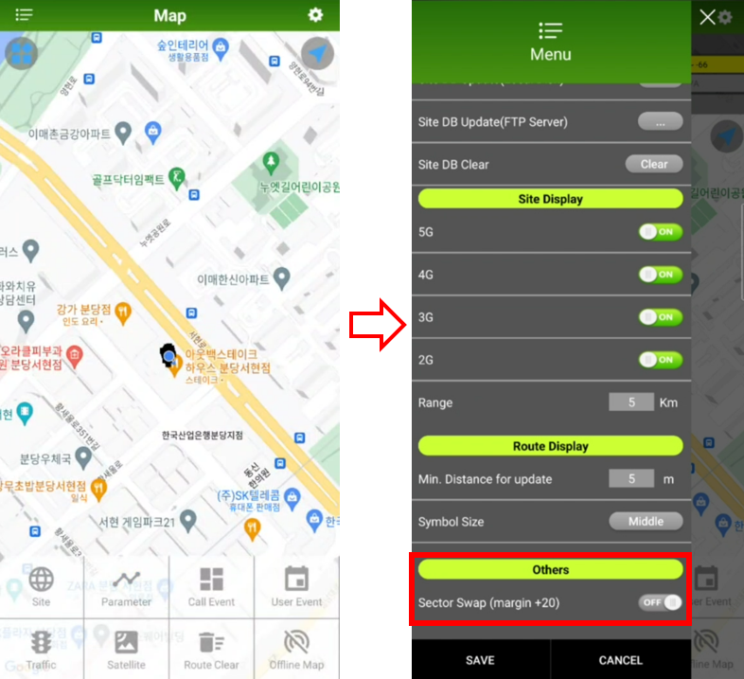
Criteria | 1. Sector Swap on/off 되는지 확인한다.  2. Sector Swap on 이후 해당 기능이 동작하는지 확인한다.  - Alram 발생하는지 확인한다.

  - Menu (Left Side) – Show my route-line on the map
Test Items | Menu (Left Side) – Show my route-line on the map
Preparations | 1. License: [Function] Map,
Test Procedure | 1. Enter Map. (See 1.1 MAP Entry Method for Map entry method).  2. Select Menu[] on the top left.  3. Check the Others area.  4. Check the " Show my route-line on the map” option.  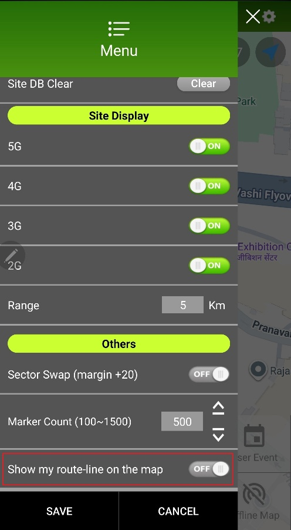  5. After saving, check if it is applied to the map.  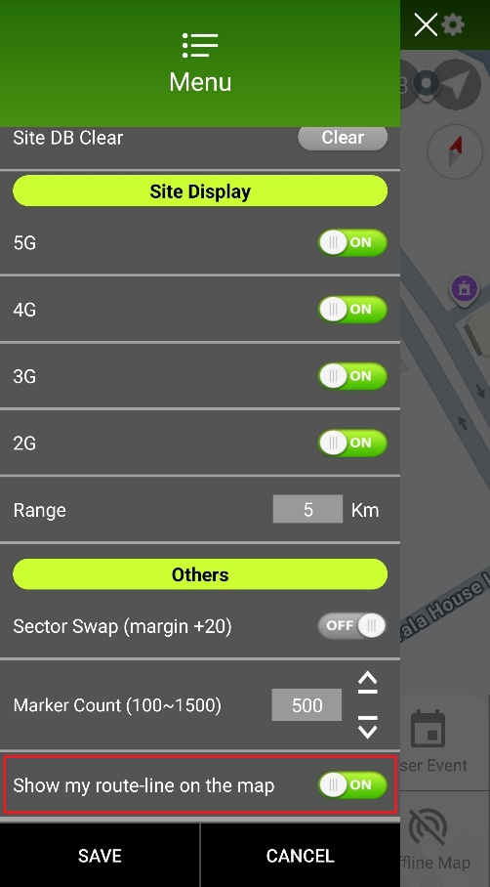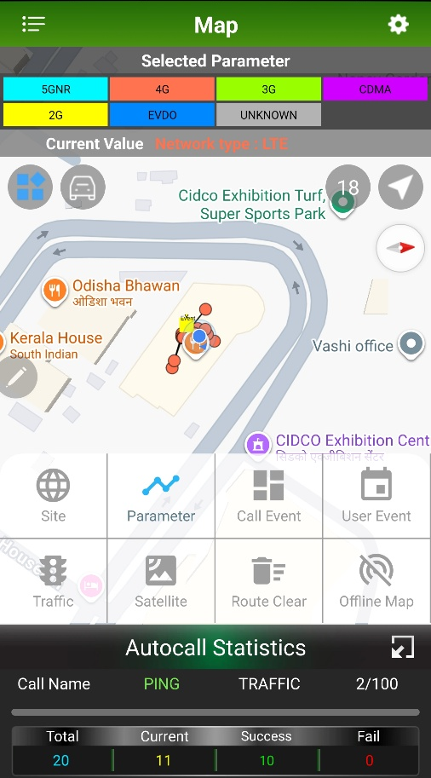  6. Turn off the “Show my route-line on the map” option.  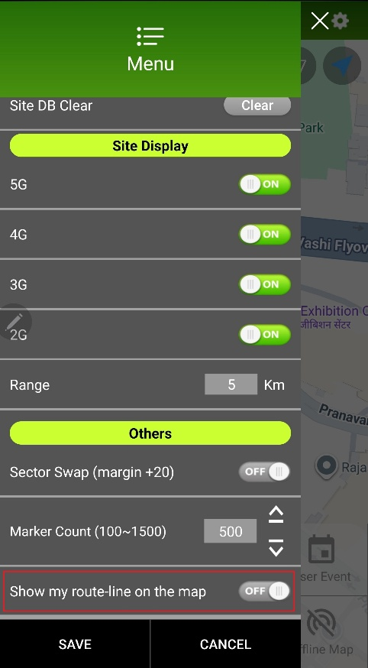
Criteria | 1. Check when the option is turned on, Polyline is generated from that point on.  2. Check when the option is turned off, check whether the toast message “Route-lines have been cleared.” And the Polyline on the MAP was deleted.  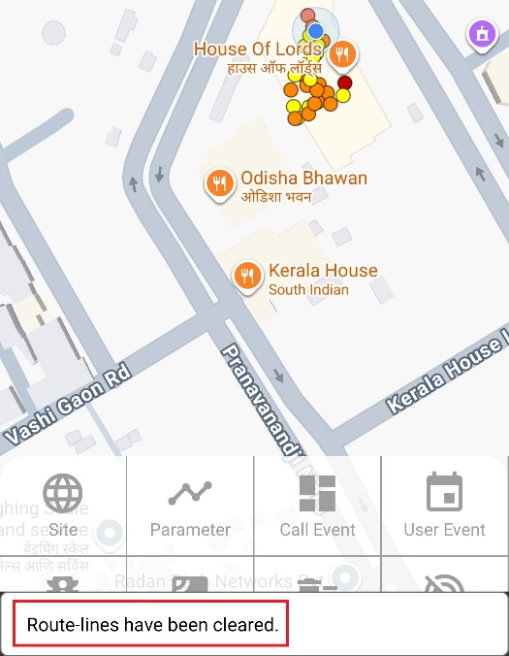
  - Main – Google Map
Test Items | Main – Google Map
Preparations | 1.License: [Function] Map
Test Procedure | 1. Enter the map. (Refer to 1.1 How To Enter the Map)  2. Check if Google Maps is displayed when entering Map .
Criteria | 1.[Menu] – [Map] Verify that Google Maps is displayed when entering.  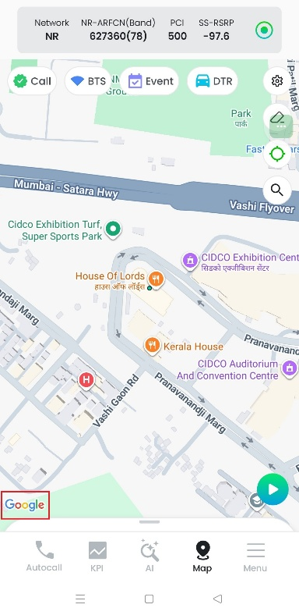

  - Main – Menu Default
Test Items | Main – Menu Default
Preparations | 1.License: [Function] Map
Test Procedure | 1. Enter the map. (Refer to 1.1 How To Enter the Map)
Criteria | 1. Of the two round buttons located just below the Map title bar, the button to open the submenu is Off, Ensure that the Auto Focus button on the current position is set to On by default  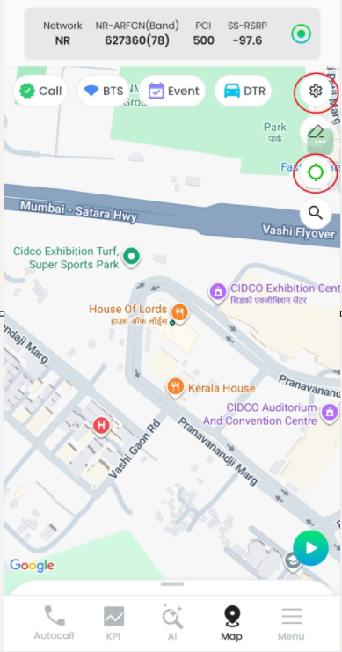

  - Main – Auto Focus
Test Items | Main – Auto Focus
Preparations | 1.License: [Function] Map
Test Procedure | 1. Enter the map. (Refer to 1.1 How To Enter the Map)  2. Try moving the map.  3. in the upper right corner of auto focus you have to touch the [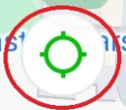] button.  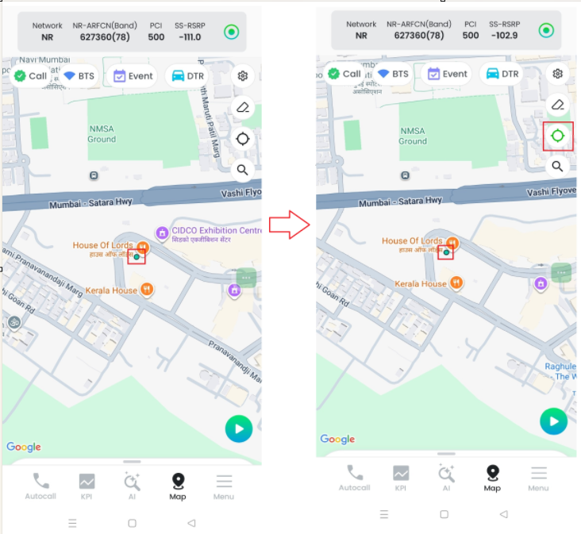
Criteria | 1. Check if the Auto Focus button is disabled when the map is moved.  2. Touch the button while disabled to check if the current position is automatically focused when enabled.

  - Main – Compass
Test Items | Main – Compass
Preparations | 1.License: [Function] Map
Test Procedure | 1.Enter Map (see 1.1 How to enter Map).  2. Rotate the map.  3. touch the Compass button [] that appears in the upper left corner when the map is rotated  .  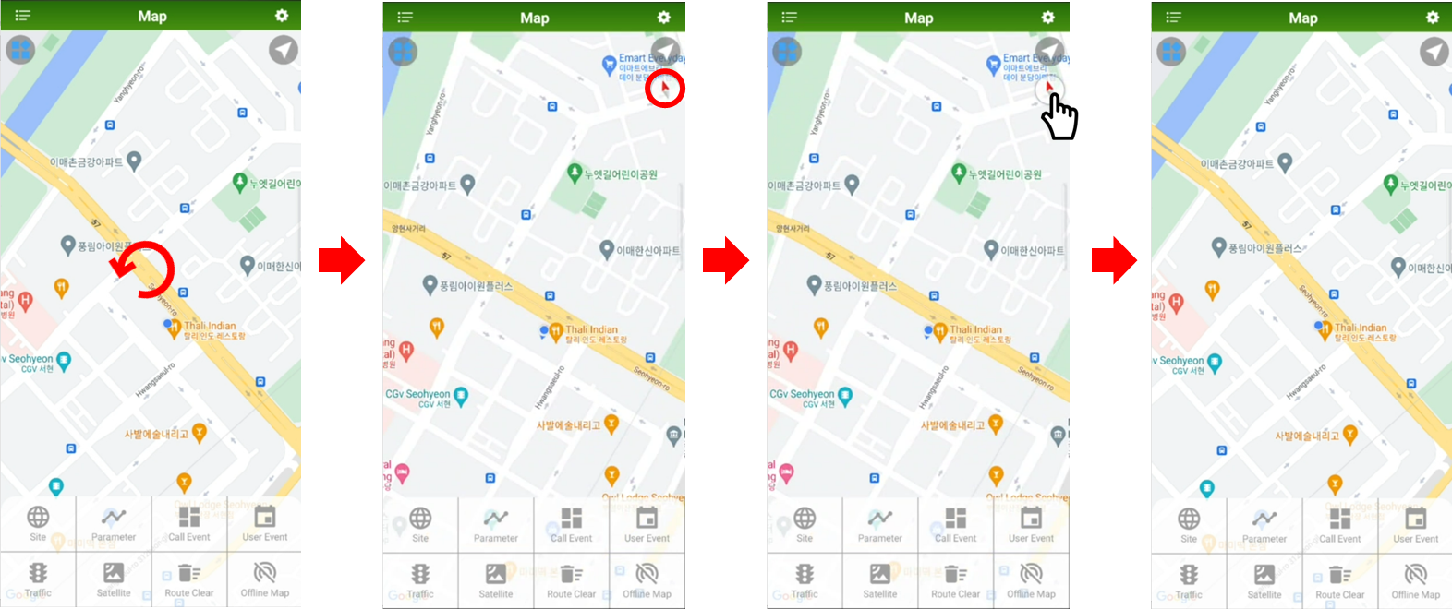
Criteria | 1. verify that the Compass button is created when the map is rotated.  2. When selecting the created Compass button, make sure that the screen rotates so that the top of the screen faces north on the map.  3. Verify that the Compass button disappears when the top of the screen is facing north on the map.

- Setting (Right Side)
  - Setting (Right Corner) – DTR Setting
Test Items | Menu (Left Side) – Open
Preparations | 1.License: [Function] Map
Test Procedure | 1. Enter the map. (Refer to 1.1 How To Enter the Map)  2. Select Menu [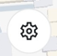 ] in the upper right corner.  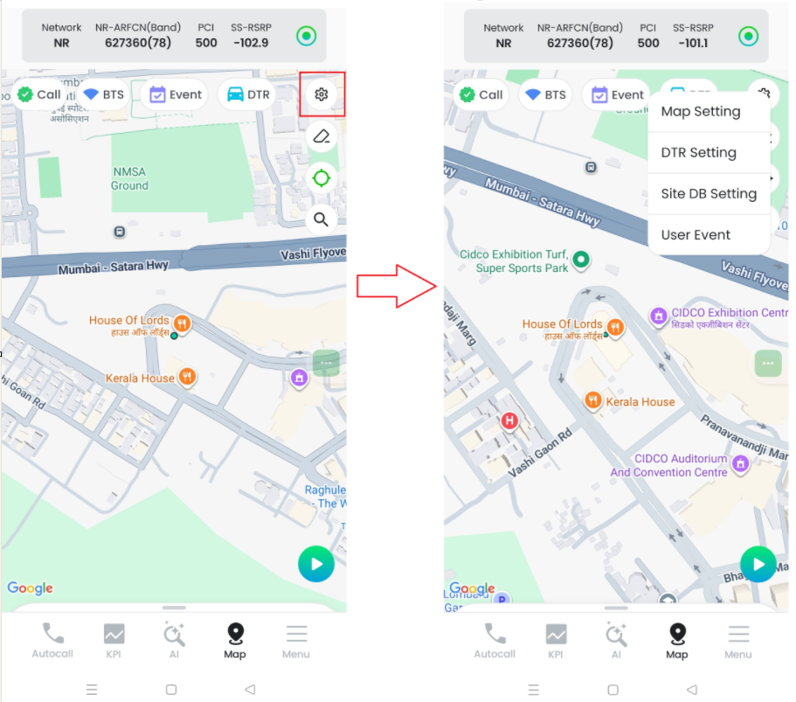
Criteria | 1. When pressing the Menu button on the left side of the Map title bar, make sure that the Menu screen opens on the left side.

  - Setting (Right Corner)– DTR Update (Mobile)
Test Items | Menu (Left Side) – DTR Update (Local Disk)
Preparations | 1. License: [Function] Map,  2. DTR (Default path set: \sdcard\XCAL-Mobile\Settings\DTR\Local)  (For DTR files, contact the administrator)
Test Procedure | 1. Enter the map. (Refer to 1.1 How To Enter the Map)  2. Click Menu [ ] in the upper right corner.  3. Click the button of DTR setting from Setting option.  4. Go to the DTR file path and select DTR from the list, and proceed with the update.  5. Verify that DTR is applied to the map.  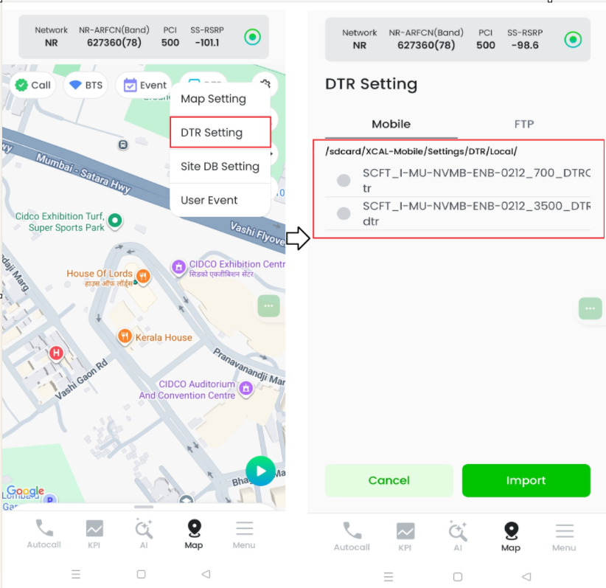
Criteria | 1. Verify that the DTR loaded from the Local Disk is updated successfully  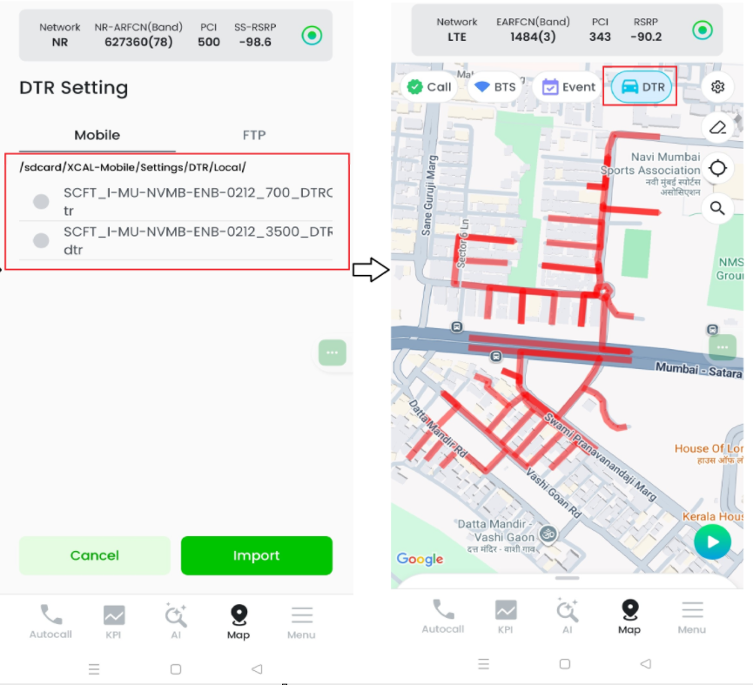

  - Setting (Right Corner) – DTR Update (FTP)
Test Items | Menu (Left Side) – Site DB Update (Local Disk)
Preparations | 1. License: [Function] Map,  2. FTP Server Information  (For FTP server, contact your administrator)
Test Procedure | 1. Enter the map. (Refer to 1.1 How To Enter the Map)  2. Select Menu [ ] in the upper right corner.  3. Click the button of DTR setting from Setting option.  4. Enter FTP server info to connect and download DTR from the FTP.  5. Check if the downloaded DTR is automatically updated.  6. Verify that DTR is applied to the map.  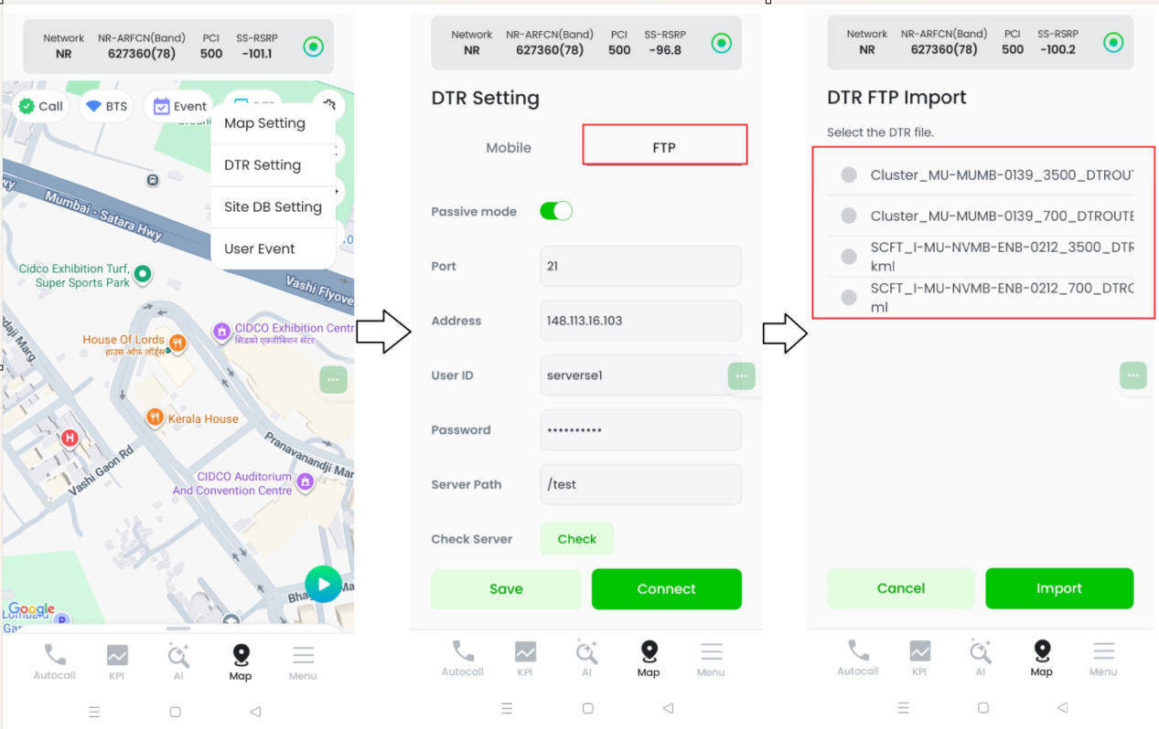
Criteria | - Verify that the DTR loaded from the FTP server is updated successfully  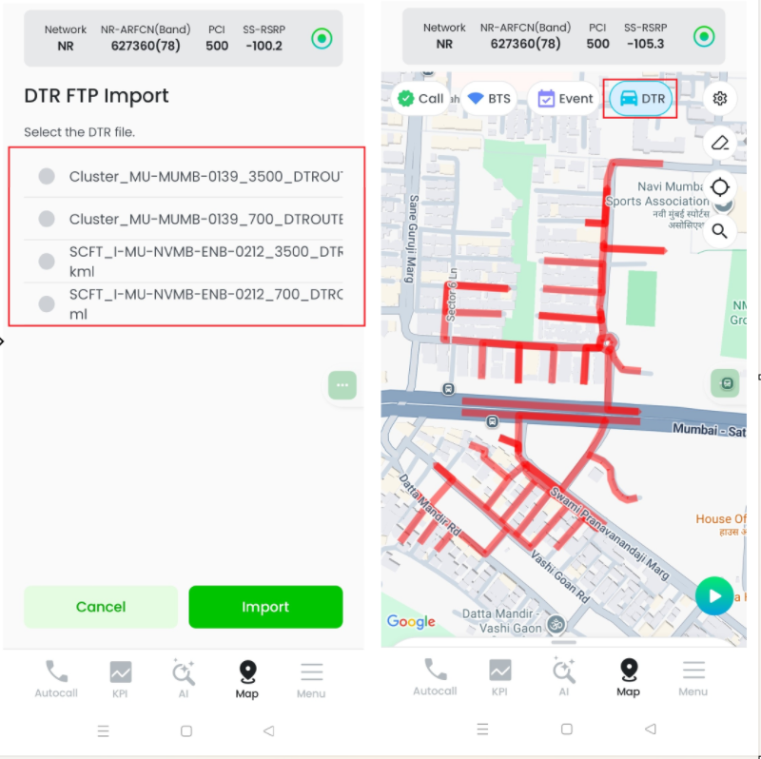

  - Setting (Second option) – DTR Clear
Test Items | Menu (Left Side) – Site DB Clear
Preparations | 1. License: [Function] Map,  2. DTR  (For Site DB files, contact the administrator and refer to the BTS Manager Guide.)
Test Procedure | 1. Enter the map. (Refer to 1.1 How To Enter the Map)  2. Select Menu [ ] in the upper left corner.  3. Select ‘DTR Clear.  4. Check that DTR is cleared on the map.
Criteria | 1. Check that DTR is cleared on the map.

    - COMMON item check
Test Items | COMMON item check
Preparations | 1. License: [Function] Map
Test Procedure | 1. Tap the [Setting]  button at the top right of the map screen.  2. Select [COMMON] at the top.  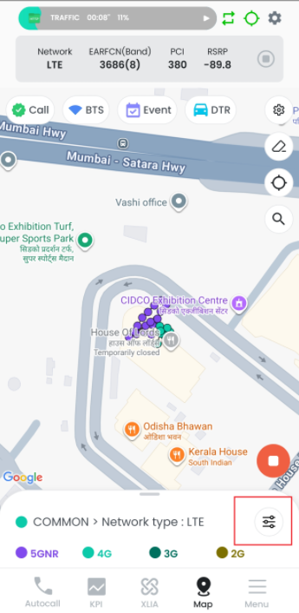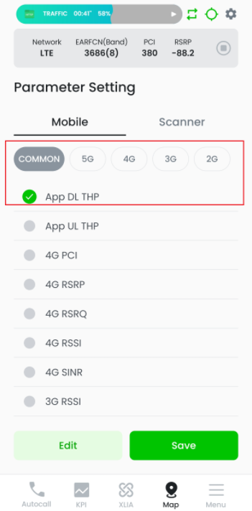
Criteria | 1.Check that COMMON items. (App.DL TP, App.UL TP, Network Type, App.DL TP(Speedtest), App.DL TP(Speedtest), Round Trip Time)  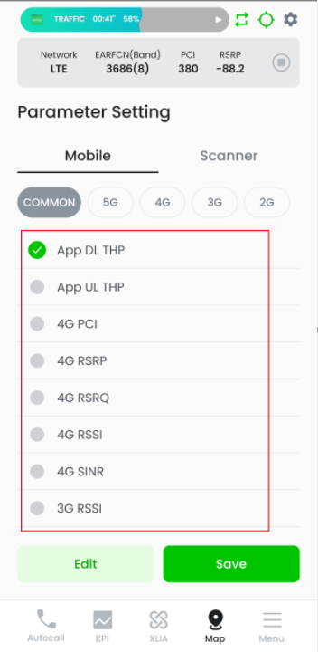

    - COMMON – App.DL TP apply
Test Items | COMMON – App.DL TP apply
Preparations | 1. License: [Function] Map  2.Map Setting: Bottom Menu – Parameter Enable
Test Procedure | 1. Tap the [Setting] button at the top right of the map screen.  2. Select [App. DL TP] from [COMMON] and tap the [OK] button.  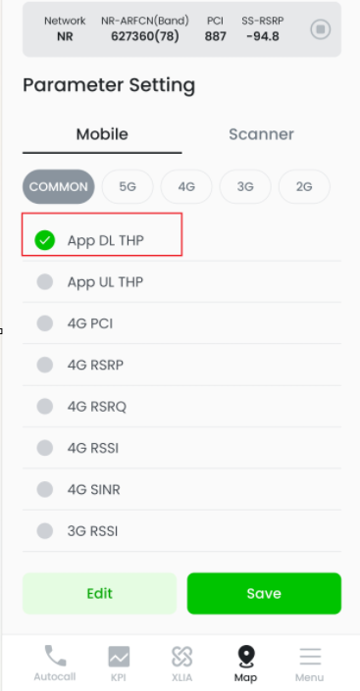
Criteria | 1.Check that the parameters displayed on the map are applied as App.DL TP.  2.Check that the color marking of the parameter displayed on the map and the legend color marking corresponding to the current value appear to match.  